Contents
- HLF Biodiversity Project – Eligibility of Private Land
- Breckland Biodiversity Audit
- Essex Biodiversity Project
- Hertfordshire Biodiversity Partnership
- Norfolk Biodiversity Partnership
- Suffolk Biodiversity Partnership
- News from Biodiversity is Life
- WREN Biodiversity Projects for 2010
- Big Lottery Fund
- Life+ 2010 – EU Programme Factsheet
- EEBF Response to new PPS on Planning for a Natural and Healthy Environment
- Definition and Mapping of Open Mosaic Habitats on Previously Developed Land
- Defra Ministerial Portfolios
- Diary Dates

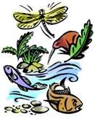
HLF Biodiversity Project – Eligibility of Private Land
HLF recently agreed changes to the eligibility of private land in biodiversity applications.
See this publication for further information (Pg14): http://www.hlf.org.uk/HowToApply/furtherresources/Pages/Thinkingaboutbiodiversity.aspx
What this means is that where the right circumstances exist, HLS could become an eligible source of match funding (it has been for landscape partnership applications for some time, but this change now means it’s eligible under Heritage Grants too which can deliver a much higher percentage of direct biodiversity outcomes than LPS).
Bearing in mind that HLF are extremely keen to support more biodiversity projects at present after the share of their grants going to biodiversity declined to 4%, and are especially keen at present given it is the International Year of Biodiversity, now would be a very good time to consider which landscape scale projects in the region could put a project together which could use the HLS money.
The sort of project I can envisage working would be where:
• we are targeting HLS
• there is an IBDA (not essential but we are promoting these to HLF at the moment)
• landowners would be supportive of being part of an HLF project
• landowners are keen to provide as much public access as is reasonable, and
• habitat works are needed next to HLS agreement holders
HLF won’t fund continuation of things that are already happening though, so ideally they would be new agreements timed to work with the project, but there may be ways of dressing current agreements to enable parts of them to work.
Essex Biodiversity Project

In 2009, our 10th anniversary year, Essex Biodiversity Project had input on 107 sites spending over £38K on projects to the value of at least £160K. This involved over 78ha+ of habitat restoration, 4.5ha of habitat maintenance and 8.5ha of habitat creation. We have worked with a least 50 different organisations, directly engaging at least 1500 members of the public. We produced at least 17 reports, 10 articles and newsletters and 3 BBC radio broadcasts and led at least 9 guided walks and talks
Fisher’s Estuarine Moth now introduced to Abbotts Hall Farm
Fisher’s Estuarine Moth is extremely rare, with Essex holding almost the whole UK population and its only food source is Sea Hogs Fennel, itself a rare plant. The Fisher’s Estuarine Moth is found on a few sites in the county, one of them being Skipper’s Island, an Essex Wildlife Trust nature reserve.

Following five years of planning and monitoring by the Essex Biodiversity Project of the host plants, the eggs of Fishers estuarine moth have now been introduced at Abbotts Hall Farm. Eggs were taken from Skippers Island last year under license and have been kept by Colchester Zoo in cages to protect them from predators and parasites.
In preparation for the moths being introduced at Abbotts Hall Farm, Sea Hogs Fennel was planted five years ago with seed from Skippers Island, the EWT reserve which is a stronghold for both these species. This is a step forward in the conservation of the Fisher’s Estuarine Moth and the introduction of the eggs is a real achievement in the protection of this rare species.

The plants will be monitored over the summer for signs that the caterpillars are feeding within the stems and roots of the plants and additional eggs will be introduced in future years.
Essex Biodiversity Project working with Kelvedon Hatch PC have been successful in obtaining c.£7500 ECC Community Initiative Fund for the sensitive restoration of Swan Pond. Works will take place in the autumn.
Several years ago Essex Biodiversity Project working with Colchester Zoo designed and created a wetland area for native wildlife on their site on the Roman River. A couple of weeks ago we undertook a follow up site visit with enthusiasts from Colchester Natural History Society and Zoo staff it was very exciting to note how quickly the site had naturalised and habitats developed. There is more work to do there to complete the facilities for access and introduce additional plant species as appropriate
Essex Biodiversity Project has been awarded £5000 from DEFRA to carry out a local hedgerow survey – the selected project is ‘Hedgerows for Hazeleigh Woods’ covering LL No. 43 and 8 LoWs in Maldon District. The initial training session for 25 volunteer surveyors is on the 11th June and work will commence over the summer. This has been a useful catalyst for engaging a major local landowner in preparation for Essex Biodiversity Project drafting the Hazeleigh Woods Living Landscape Vision Document
Essex Biodiversity Project are working with Martin Pugh of EECOS with funding from the EA to eradicate signal crayfish from a pond at Great Dunmow which is close to the river Chelmer. This stretch of river is home to a population of native white clawed crayfish and the close proximity of the signal crayfish is a major threat to this population.
Essex Biodiversity Project are pleased to join the Essex Rural Partnership. The Essex Rural Partnership brings together key organisations in Essex (and some regional bodies) to consider, debate and act on major issues affecting the rural parts of the county. The vision is to create an environmentally and economically sustainable future for rural Essex, based upon :

- local diversity and identity, conserving and enhancing the natural, built and historic environment;
- Thriving, economically diverse and inclusive communities that provide a good quality of life for all;
- Increasing biodiversity and managing the impact of climate change;
- Increasing accessibility to the countryside.
The Essex Rural Partnership encourages not only co-ordination of activities, to maximise effectiveness of resources, but also joint-working to achieve greater buy-in, better chance of securing funding, and best value. ERP Website: www.essexruralpartnership.org.uk ,

Essex Biodiversity Project have met recently with Paul Hewitt of Epping Forest District Council and Marcus Hotten of Basildon District Council to support the revision of their local Biodiversity Action Plans, harmonising them with the Essex BAP as the draft is completed.
Essex Biodiversity Project ran another Dormouse survey course at Norsey Wood to train interested volunteers and professional on dormouse ecology, habitat requirements and the tube survey method, c20 people attended. Several hundred survey tube kits have gone out to support surveys by Essex & Suffolk Dormouse Project and the presence of dormice has been confirmed at Hylands Park, Chelmsford.
Following the writing and delivery of the Pincey Valley Living Landscape vision document by Essex Biodiversity Project we were contacted by Hatfield Broad Oak Parish Council and Uttlesford DC for our input on the creation/restoration of habitat associated with a sports/recreation area in the village. We are keen to support the PC and get the maximum biodiversity benefit from the project which dovetails well wit the Living Landscape vision.
Essex Biodiversity Project participated in the regional Integrated Biodiversity Delivery Areas (IBDA’s) workshop organised by NE and EEBF. Argued for Thames estuary/ Essex Coast for selection but the three IBDA’s for this region chosen were Brecks, Fens and Suffolk Coasts and Heaths. However there may be still some benefit for Essex from this process. We are working with the London region to take forward a ‘Thames Tributaries’ IBDA which would include a number of Essex rivers, including the Stort, Ingrebourne, Mardyke etc. A boundary for this has been agreed.
This is the final year for the Gt Bardfield oxlip project. The plants have established well and there is a final planting day planned for the autumn. The density of the plants has been monitored by the school pupils and the sites will be maintained by the Parish Council. This has been a excellent project inspired and led by Ray Tabor with fantastic support form Doug Joyce a local horticulturalist which has left a real legacy for the village.
Essex Biodiversity Project are working the landowner and Pat Hatch of EECOS to design and install a winter Bat hibernaculum at Sunnymead farm, near Arlesford. This feature forms part of the restoration of the mineral extraction site as part of the ongoing HLS scheme.
Each year, Essex Biodiversity Project the presents its Quality of Life award and we are looking for this years winner.

This award is open to any individual, group or organisation active within Essex who in the opinion of the EBP steering group deserves to be recognised for their outstanding contribution to enhancing and promoting biodiversity.

In 2009 the Essex Biodiversity Project were delighted to present the award to the Friends of Tiptree Heath for their tireless work.

Last year, what so impressed the EBP Steering Group is how the Friends harnessed the professional conservation community – Natural England, The Essex Biodiversity Project, Essex Wildlife Trust, Colchester Borough Council and others to help them deliver their vision for the heath as a thriving area for wildlife and the people of Tiptree. The Friends took on the very difficult project of introducing grazing to the heath (a SSSI and a registered common) and explained and educated users of the heath over several years. The Friends have a very long standing commitment to the site and have worked tirelessly on the heath for many years with weekly work parties – clearing paths and scrub, working with and connecting everyone to ‘their’ heath and celebrating the site with the annual heath fair.

With the Quality of Life Award trophy comes £500 as a contribution to support the recipients ongoing work.

The deadline for entries is Friday 16th of July. The EBP steering group meets on 5th of August to consider the nominations and the 2010 winner will be informed shortly afterwards.

The award will be presented at the Essex Biodiversity Celebration meeting held at the Wat Tyler Environment Centre, Basildon on Friday the 12th of November 2010 with an invited audience from the Essex nature conservation community.

We will publicise the winners of the award widely and will get good promotion during this ~ 2010 International Year of Biodiversity.
If you wish to put forward a nomination simply contact Mark Iley – Coordinator Essex Biodiversity Project
Date of the annual Essex Biodiversity Project Celebration meeting will take place on the 12th November at the new Wat Tyler Environmental Centre, Pitsea, Basildon. The theme of the event will be ‘Ecosystem Services’ and the Essex Biodiversity Project Quality of Life award will be presented, we will also have short walks to view the extensive habitat creation and management on the site. Everyone is welcome, please contact me if you wish to attend.

Hertfordshire Biodiversity Partnership

The Hertfordshire Biodiversity Action Plan newsletter for 2009, produced by the Hertfordshire Biodiversity Partnership, has been sent to all councillors across the district and borough councils in Hertfordshire and all the district LSP Boards. As well as highlighting progress with the delivery of the habitat and species action plans, the report also identifies a variety of biodiversity projects being carried out across the county and can be viewed on the HEF website at: http://www.hef.org.uk/nature/action_plan_highlights_2009.pdf.

The Quality of Life Report 2009, produced by the Hertfordshire Environmental Forum, has been published and is available at: http://enquire.hertscc.gov.uk/qol/

The ‘wildlife’ chapter (http://enquire.hertscc.gov.uk/qol/2009/wildlife09.cfm), collated by the Hertfordshire Biological Records Centre, illustrates the results of biodiversity monitoring taking place across the county – in particular changes observed with our wildlife indicators of water voles, birds, hares, butterflies, damselflies and dragonflies, wildlife sites and condition of SSSIs. It also includes a brief summary of progress with the delivery of the Herts Biodiversity Action Plan during 2009.

Hertfordshire Orchard Initiative (HOI) have completed the development of a Traditional Orchards Action Plan for Hertfordshire which can be viewed on the HEF website shortly. HOI are working with the Woodland Trust, helping them design and plan the planting of an orchard at Heartwood Forest near Sandridge, St Albans and are busy providing juicing demonstrations at Country Fairs and events.

The Hertfordshire Woodland Forum are in the process of revising the Woodland Habitat Action Plan for Hertfordshire taking into account the regional and national targets.

The partnership is working with PTES on their Hedgerows for Dormice project, a Countdown 2010 funded initiative which is focusing on the Chilterns this year. Using local dormice records, PTES have identified dormice ‘hotspots’ where they intend to start aerial mapping of hedgerows. Ground truthing by volunteer surveyors trained at Hedge Survey Workshops will then follow.

Stevenage Borough Council ran a very successful Springwatch Wild Day Out event at Fairlands Valley Park on Sat/Sun 5/6th June where they launched their newly written Biodiversity Action Plan.

HEF approved a funding proposal from the partnership for a small Biodiversity Projects Fund of £5k towards the delivery of partnership activities (as outlined in the partnership work plan) and to support species-related initiatives which are less eligible for external funding and might be delivered entirely through volunteers.

Norfolk Biodiversity Partnership

Highlights since the last meeting of the Regional Biodiversity Forum have included the following:

Norfolk Non-native Species Initiative
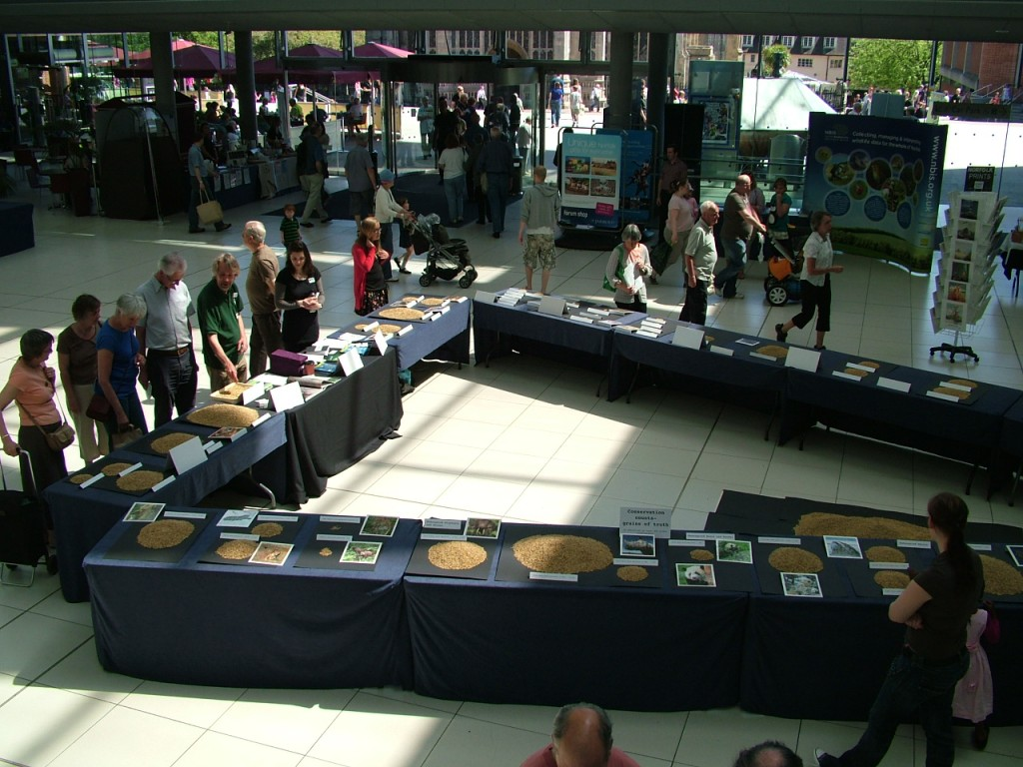
A wide range of field activities is now underway, including projects aimed at eradicating floating pennywort on the River Waveney, controlling giant hogweed along the Yare and mapping Himalayan balsam on the Wensum. The NNNSI Stakeholders’ Forum in March attracted over 50 participants, and included not only an impressive array of national and local speakers, but also, a series of practical, “hands-on” identification workshops.

Brecks Biodiversity Audit
The Brecks Audit has continued to make excellent progress. Over 575,000 records have been collated to date, representing some 12,735 species. Of these, nearly 2,000 are Red Data Book/ Notable/ BAP species - highlighting the exceptional biodiversity importance of the Brecks. Partly as a result of the work of the project, the Brecks were identified as an “Integrated Biodiversity Delivery Area” at a regional workshop convened by Natural England. The first phase of the project is due to conclude in November and an official launch of the report is being planned.

International Year of Biodiversity
In collaboration with the Norfolk Wildlife Trust (NWT) and the Norfolk Biodiversity Information Service (NBIS), a special event to mark the International Day of Biodiversity was held on 22 May at the Forum in Norwich. This featured the innovative “Grains of Truth” display, developed by David North to convey facts and figures about biodiversity using grains of locally-grown barley. It also featured displays by NBIS and the Norfolk Non-native Species Initiative, including a “life-size” alien spaceship and live examples of several invasive species. Additional events to commemorate IYB are being planned, including a biodiversity conference for 6th formers (being organised in collaboration with the Castle Museum) and a study day to look at the connections between biodiversity and art (in collaboration with the Sainsbury Centre for the Arts).
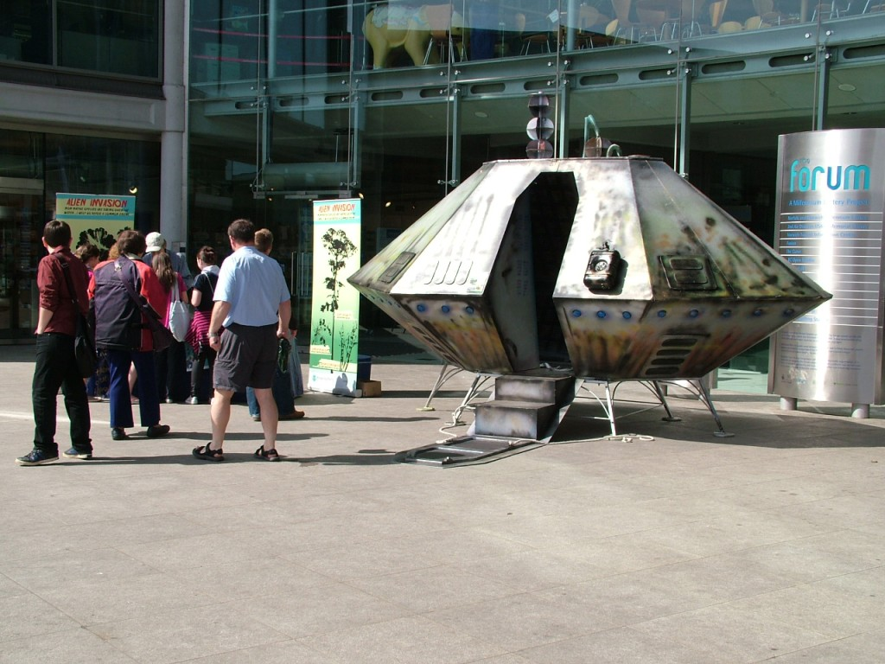

Biodiversity Project Fund
Norfolk County Council has generously renewed its contribution to the Biodiversity Project Fund, and this has enabled grants to be offered to a range of projects, including work on wetland and coastal County Wildlife Sites, pingos, invasive species and heathland restoration.

Action Plans
The Fen Orchid Action Plan has been substantially revised by Plantlife, and is now nearing finalisation. Significant progress has also been made on the action plan for Open Mosaic Habitats on Previously Developed Land; a complete first draft is now available and is under review and discussion. Work on the revision of several other plans has also been initiated, including the action plans for fens and reedbeds.

News from Suffolk Biodiversity Partnership

SBP Shines at the Suffolk Show
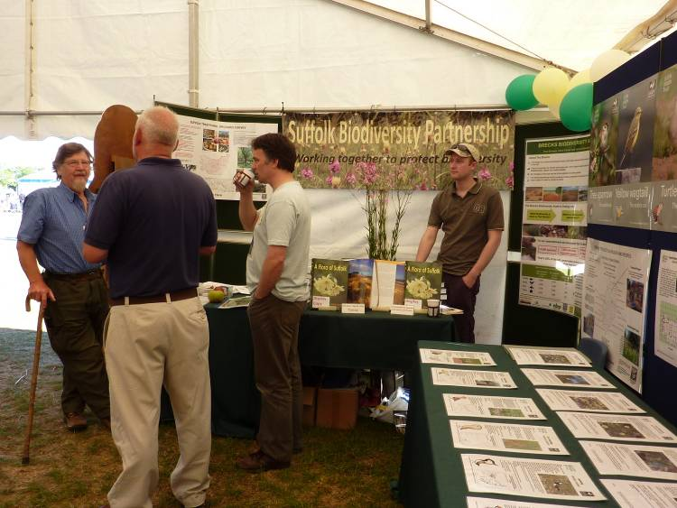
SBP had a very successful Suffolk Show on 2 and 3 June. With glorious weather to bring in the crowds, we were delighted to greet partners and many others interested to hear about our work for the first time. The stand featured our county-wide traditional orchard survey, an inspiring Suffolk Coastal communities’ project, the high profile Brecks Biodiversity Audit and Martin Sanford’s new Flora of Suffolk, published March 2010.

SBP’s stand at the Suffolk Show: Paul Read (left) discusses traditional orchards with Steve Piotrowski (Suffolk Wildlife Trust), Martin Sanford and Ben Heather (Suffolk Biological Records Centre). Photo: Gen Broad
A huge ‘Thank You!’ to Suffolk Wildlife Trust, a member of the Suffolk Biodiversity Partnership, for inviting us to share their facilities at the show.

Suffolk Aims High!
Biodiversity Action Plan (BAP) Review 2010
Section 41 of the Natural Environment and Rural Communities (NERC) Act 2006 required the Secretary of State to publish a list of habitats and species which are of Principal Importance for the conservation of biodiversity in England. This resulted in a huge number of species and habitats being added to the UK list by Natural England. Suffolk has responded by initiating an ambitious review of the entire county BAP.

We are taking advantage of this opportunity to align the BAP with partners’ workplans and visions, making them more streamlined and effective. Our aim is to make the plans truly SMART with achievable targets and realistic actions. There will be three categories: habitat plans which will incorporate species when possible, individual species plans (for example otter) and grouped species plans, for example bats and widespread reptiles.

SBP is delighted to announce that, thanks to Suffolk Biological Records Centre and the county’s biological recorders, we now have a comprehensive list for Suffolk comprising 143 species and 26 habitats. We have made a start in drawing up plans in the new format with saltmarsh and mudflats, little tern and arable field margins plans. The new plans will be published on our website as they are completed with the aim of completing the review by autumn 2010.

The new list and further information is available on our website: http://www.suffolk.gov.uk/Environment/Biodiversity/BiodiversityActionPlans.htm

Tower Mustard and the Heathland Habitat Working Group
The Heathland Group focussed their May meeting on ways to identify and map the location of all heathland sites throughout Suffolk. The group then headed outdoors to discuss the new Action Plans, followed by a rare chance to see tower mustard on a Forestry Commission site. Once well distributed in Suffolk, tower mustard is now confined to areas such as the Brecks where open areas and extensive grazing provide suitable conditions, for example at Barnhamcross Common near Thetford. Although Nationally Scarce and classed as Endangered, tower mustard is thriving in a few regularly disturbed sites in Breckland.
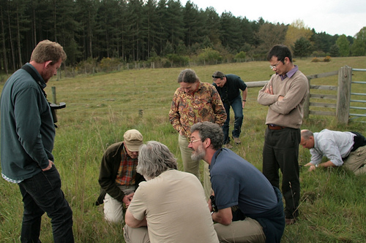

The SBP Heathland Habitat Working Group on a site visit.

Left to right: Neal Armour-Chelu (Forestry Commission), Rob Parker (Butterfly Conservation), Mel Kemp (RSPB), Monica O’Donnell (Natural England), Dave Mason (Suffolk Wildlife Trust), Bev Nicholls (Natural England), Chris Burton
(Forest Heath District Council), Neil Featherstone (Brecks Partnership).
Photo: Ben Heather

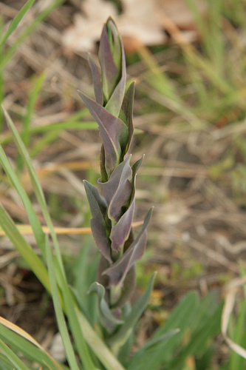
Tower mustard Arabis glabra on a Forestry Commission site in Norfolk
Photo: Ben Heather

SBP Newsletter
To find out what’s happening for biodiversity in Suffolk, take a look at our popular SBP e-newsletter. This is packed with news about partner projects, updates on what the Partnership is doing, national and local biodiversity reports and news, information about grants, conferences and What’s On.

The May newsletter included Environment Agency work with eels, Suffolk County Council's work with black poplars and orchards, the Broads Authority at Lound Lakes, an update from St Edmundsbury Borough Council on Nowton Park and Butterfly Conservation on the dingy skipper.

The newsletter is available on SBP's News and Events webpage: http://www.suffolk.gov.uk/Environment/Biodiversity/NewsAndEvents.htm
News from Biodiversity is Life

IPBES
As signalled in the last newsletter, a declaration for the establishment of the Intergovernmental Science Policy Platform on Biodiversity and Ecosystem Services (IPBES) was agreed in Busan, South Korea. The news was covered by The Times on 12 June, The Daily Telegraph on 14 June and The Guardian on 11 June, which carried a quote on the issues from IYB-UK secretariat.

Putting Nature on the Map
IUCN-UK National Committee is to lead an exercise in identifying places in the UK which meet the new (2008) IUCN definition of ‘protected’ areas. It will be an important contribution to the International Year of Biodiversity, and aims to be completed in 2011. A new project co-ordinator will be appointed to lead the task force – further details can be found on the project website.

Skills for Wildlife: Conservation Traineeships for Young People
Congratulations to Sheffield, Yorkshire and Derbyshire Wildlife Trusts who are the latest organisations to have been awarded an HLF grant. The £345,800 grant to train young people in biodiversity-focused land management skills is shared jointly. Participants will learn skills including coppicing, hedge laying and dry stone walling, species identification and the use of tools and machinery. Sixteen young people, aged between 16 and 19, will undertake full-time training for one year with the aim of achieving an NVQ in Environmental Conservation or Land-based Operations.

Bradford Mayor’s Parade and Mela Festival Bradford
Congratulations to Bradford City Council for their fantastic efforts to promote the International Year of Biodiversity. The Lord Mayor’s Parade was costumed to mark Year of the Tiger and was dedicated to the IYB, while the Mela celebrated biodiversity in its great programme of multi-cultural activity. The council’s team profiled biodiversity in the city park where the festival was held and made extensive use of the IYB branding on all the event fliers and programmes.

London does Biodiversity
Union Street Urban Orchard
As part of the London Festival of Architecture a part of London in SE1, centred on Union Street, is to be transformed into an urban orchard and community garden 3-4 July. Curated by The Architecture Foundation and designed by Heather Ring of the Wayward Plant Registry it will be built with local gardening group, Bankside Open Spaces Trust and an array of volunteers to regenerate a disused site and create a place for exchange between local residents and visitors to the Festival while hosting a range of the activities.

Bees in the Belfry??
Meanwhile the roof of St Paul’s is now home to thousands of bees, installed in a new hive as part of IYB-UK partner the City of London Festival’s programme.

Life Between the Lines
Life between the lines is a competition to showcase the work being done to improve the Capital’s environment and support biodiversity. It is a partnership project run by London Underground and the Royal Society for the Protection of Birds as part of their commitment to the International Year of Biodiversity 2010. In addition to a photographic competition there is also a prize for interesting biodiversity initiatives around the capital.

Forthcoming Events and Conferences
GBOB developments
The new Secretary of State for Environment, Food and Rural Affairs will use GBOB (Global Business Of Biodiversity Symposium July 13) as an opportunity to look at UK policy on biodiversity. In the concluding session Angela Cropper, Deputy Director of UNEP, and Ravi Sharma, the Head of the Business and Biodiversity team of the CBD, will be looking at the importance of mainstreaming biodiversity management into economic and business thinking.

The chance to send IYB-UK partner delegate’s to GBOB for free has been extend until the end June - visit https://www.eventsforce.net/oasis/138/register and use the reference code IYBDEL to book your free places. There are currently over 40 organisations with stands in the exhibition space, and just a few stands remain – it’s not too late to discuss this with John Brown if you have been considering this option: John Brown at Ten Alps on 07768 950028.

The End of Tradition?
The End of Tradition is an academic conference planned by Sheffield Hallam University for 15-17 September, looking at landscape history and change, cultural change and abandonment. The conference will have an international focus bringing together researchers from around the world. Prefaced by the words The Biggest Threat to Biodiversity in the 21st Century it will highlight the relationship between landscape, culture and biodiversity.

In the Media
The Royal Botanic Gardens Kew have rediscovered, and rescued a fern in the Ascension Islands that was presumed extinct for 60 years.

The Guardian, Natural England and Oxford University Museum of Natural History have launched a competition to give common names to unloved and lesser known UK species.

Michael McCarthy of the Independent looks at the small species: spare parts that matter commenting on the importance of research into the decline in insect species, particularly those so important to pollination.

On www.biodiversityislife.net
The latest View essay has been written by David Shreeve, Environmental Advisor for the Church of England. It highlights the often overlooked biodiversity resource of churchyards as it is Cherishing our Churchyards week. Our What’s on highlights include National Insect Week, City of London Festival and the Postcards from the Park photo competition.

And finally
IYB the fastest brand on two legs
Some time ago the Convention on Biological Diversity working with the UNEP sports initiative arranged for the African nations second strip to carry the IYB logo. To promote this they have also enrolled Usain Bolt, the world’s fastest man. Just a media exercise – maybe – but one which might just reach some of the millions of viewers globally watching the world cup (come on England by the way).


WREN Biodiversity Projects for 2010



Launch of the Big Lottery Fund's Community Wildlife Programme
The Big Lottery Fund has teamed up with the BBC to launch the Community Wildlife Programme, which brings communities together to improve or protect the natural environment by raising awareness of threatened wildlife or places.
The programme celebrates 2010, the International Year of Biodiversity, by allowing local groups and communities to get more involved with, enhance and protect their local wildlife. Not-for-profit organisations, social enterprises, local councils and schools or health bodies may apply for support.
Grants of between £300 and £10,000 are being provided for one-year projects that:
- Improve rural or urban environments for people to enjoy, for example by:
  - protecting wildlife habitats;
  - creating a nature trail, woodland walk or wildlife garden; or
  - improving community spaces such as rivers, ponds, woodlands.
- Projects that get people more active and healthier, for example by:
  - exploring parks, rivers and the countryside to look for rare or endangered species;
  - encouraging people to take up gardening or to go on nature walks; or
  - providing opportunities for children to learn about nature through play.
Community Wildlife will be officially launched on the BBC's Springwatch show on Tuesday 8 June at 8pm.
The programme has three funding rounds. The deadlines for receipt of applications for each round are 21 July 2010; 22 September 2010 and 24 November 2010.
2010 LIFE+ application package

The most important changes compared to the 2009 package are the following:

Changes common to the three strands:

1. Indicative lists of types of projects which the Commission would welcome have been introduced in the application guides of the three strands.

2. A new obligatory action concerning networking has been introduced.

3. Project indicators have been removed from the application guide and forms and they will have to be provided with the submission of the inception report.

4. The selection process will be shortened from 14 months to 12 months.

5. Applicants that are scored as non-viable based on their economic performance indicators will not be automatically excluded. A financial guarantee will be requested instead.

6. The payment scheme has been modified: There will be from 2 up to 4 payments depending on the project duration and amount of the EC contribution.

Changes only related to the Nature and Biodiversity strand:

1. The full purchase cost of durable goods in Biodiversity proposals is now eligible.

2. The eligibility of setting up and testing recurring activities has been clarified.

3. Co-financing for LIFE+ Nature addressing priority habitats and/or species of the Birds and Habitats Directives have been modulated (new rates are 50, 60 and 75%) depending on the percentage of the concrete actions addressing the priority habitats and/or species.

4. Proposals aimed at inventories for NATURA 2000 in territorial waters are eligible.

5. References to sustainability requirements have been reinforced in the evaluation guide.

Consultation paper on a new Planning Policy Statement: Planning for a Natural and Healthy Environment – Questions and response form
Name:
Respondent category: | Public (individuals not affiliated to any group)  Business (including business trade associations)  Charities, environment and community groups  Government bodies (regional planning bodies, local  authorities, government agencies and non-departmental government bodies)  Professionals and academics (including representative  bodies for professionals)
If this is not an individual response, which organisation do you represent?
East of England Biodiversity Forum (EEBF)

Who does the organisation represent?
EEBF is composed of representatives from a wide range of governmental and non-governmental organisations involved in nature conservation in the East of England. Membership currently comprises representatives from: Aggregate Industries; Anglian Water; British Trust for Conservation Volunteers; Broads Authority; East of England Development Agency; East of England Local Government Association; Environment Agency; Farming and Wildlife Advisory Group; Forestry Commission; Landscape East; the local Biodiversity Action Plan partnerships of Bedfordshire and Luton, Cambridgeshire and Peterborough, Essex, Hertfordshire, Norfolk and Suffolk; Local Records Centres; National Trust; Natural England; Royal Society for the Protection of Birds; Wildlife Trusts; and Woodland Trust.
Please give a summary of the organisation’s role
EEBF has identified seven principal roles:

- To influence national, regional and local policy related to biodiversity;
- To oversee the mapping of regional biodiversity;
- To produce regional biodiversity audits;
- To establish regional biodiversity targets;
- To stimulate new biodiversity projects;
- To communicate good practice and success;
- To support local biodiversity action.
If applicable, how have the views of members been assembled?
The views presented in this response have been collated via an email exchange with members. However, it is important to note that individual member organisations of EEBF may have their own opinions on the draft PPS and may be submitting separate responses to the consultation; these may not necessarily align with all the views and recommendations presented here.
Address: | C/O East of England Development Agency  Business Centre  Station Rd, Histon  Cambridge  CB4 9LQ
E-mail address: | CatherineWeightman@eeda.org.uk
Confidentiality: | Please tick if you wish your responses to be treated as confidential and provide reasons for this request (see paragraphs 4 in ‘The consultation process’ section of the consultation document).
Definition and Mapping of Open Mosaic Habitats on previously Developed Land

The final report has been published today on the Defra website at:

http://randd.defra.gov.uk/Default.aspx?Menu=Menu&Module=More&Location=None&ProjectID=16067&FromSearch=Y&Publisher=1&SearchText=open%20mosaic&SortString=ProjectCode&SortOrder=Asc&Paging=10#Description

DEFRA Ministerial Portfolios Announced

The portfolios for the new Defra Ministerial team have been agreed as follows:

Secretary of State (Caroline Spelman MP):
- Overall responsibility for departmental policy; particular interest in CAP reform, biodiversity and climate change
- Strategy, budget and finances
- Legislative programme
- Emergencies
- EU and international relations.
- Environment Agency
- Natural England

Minister of State for Agriculture and Food (Jim Paice MP)
- Farming
- Food
- Animal health (including endemic and exotic diseases)
- Responsibility and cost-sharing
- Welfare of farm animals
- Single Payments Scheme
- RDPE
- Forestry (including Forestry Commission)
- Agriculture and forestry carbon budgets
- Hunting and shooting
- Agricultural Wages
- Gangmasters Licensing
- Seasonal Agricultural Workers Scheme (SAWS)
- Better regulation
- Deputising for the Secretary of State at EU Agriculture Council

Parliamentary Under-Secretary for Natural Environment and Fisheries (Richard Benyon MP)
- Natural environment
- Ecosystem services
- Biodiversity
- National parks and areas of outstanding natural beauty
- Wildlife
- JNCC
- Flooding and water (including Nitrates)
- Inland waterways (including British Waterways)
- Land management (including commons and contaminated land) and soil
- Rural Affairs
- Coastal erosion
- Marine and Coastal Access Act implementation
- Marine Management Organisation
- Coastal and wider access, countryside and rights of way
- Marine Environment
- Fisheries, including CFP
- EU Fisheries Council
- Departmental administration
- Apprenticeships

Parliamentary Under-Secretary (Lord Henley)
- Environmental regulation
- Air quality
- Local environmental quality, including noise
- Royal Commission on Environmental Pollution
- GMOs
- Nanotechnology
- Chemicals and pesticides (inc CBRN)
- Local and regional government
- Localism and third sector
- Climate change – adaptation
- Climate change – Defra’s interest in mitigation and overall carbon budgets lead
- Sustainable development
- Sustainable Consumption and Production
- Biofuels
- Welfare of companion and wild animals
- Dangerous Dogs
- Bee health
- Plant health
- Kew Gardens
- Science, evidence and research
- Waste and recycling
- Global monitoring of environmental security (GMES)
- All departmental business in the Lords
- Deputising for the Secretary of State at EU Environment Council

Notes to Editors

- Caroline Spelman has been the Member of Parliament for Meriden since 1997. In Opposition, she served in the Shadow Cabinet, covering the Environment, International Development and Communities and Local Government portfolios, as well as holding other senior posts.
Before entering Parliament, Caroline had an extensive career in the agriculture sector, with fifteen years in the agriculture industry and in-depth experience of the international arena, including as deputy director of the International Confederation of European Beet Growers and a research fellow for the Centre for European Agricultural Studies. She has also authored a book on the non-food use of agricultural products.
Caroline is fluent in French and German and holds a BA First Class in European Studies from Queen Mary College. She is married with three children.
- Jim Paice has been the MP for South East Cambridgeshire since 1987, and before joining Defra was twice the Opposition spokesperson for Agriculture and Rural Affairs. He has also been spokesperson for Home Affairs.
Mr Paice held ministerial posts at the Department of Education and Employment and the Department of Employment from 1994 to 1997. He also served as Parliamentary Private Secretary to two Ministers.
Mr Paice has a lifelong involvement with farming. He was a key figure in the Young Farmers movement, and represented the UK on the European Council of Young Farmers for four years. He was a member of the Suffolk Coastal District Council between 1976 and 1987 becoming the Chairman in 1983.
Mr Paice is married with two sons.
- Richard Benyon has been MP for Newbury since May 2005. Before coming to government Mr Benyon served as a Shadow Minister for the Environment, Fisheries and Wildlife. Prior to this appointment he was a Party Whip. He has also served on the Home Affairs Select Committee.
Mr Benyon lives in West Berkshire where he is a farmer. He is a former soldier and is a founder Trustee of the charity Help for Heroes. Mr Benyon is married to Zoe, with whom he has two sons. He also has three sons from his previous marriage.
- Lord Henley entered the House of Lords in 1977 and has held a number of front bench positions both in Government under Margaret Thatcher and John Major and in Opposition. His political career has included posts as House of Lords Whip and Ministerial positions at the Department of Social Security, Department for Employment, Ministry of Defence and Department for Education and Employment. Since 1997 he has served as Opposition Chief Whip in the House of Lords and later as a Shadow Justice Minister.
Lord Henley was educated at Clifton College, graduated from Durham University and was called to the Bar in 1977.
Diary Dates

Friday 23 July 2010

The next East of England Biodiversity Forum meeting is going to be at Dragonfly House in Norwich which is approximately a 15 minute walk from the train station. There is no parking at Dragonfly House.

The meeting will start at 10:00 and finish at 13:00 with lunch provided.

There will be a minibus to Barton Broad for a boat trip (the boat will only hold 12 - so there may have to be two groups and a shorter boat trip). The minibus will hold 17 people so it is important to know numbers and see if a car is also required.

The minibus will drop people off at Norwich train station at around 16:30 but this will be confirmed on the day.

The agenda for the morning meeting will be a usual mixture of updates, looking at the Regional Biodiversity Forum Delivery Plan and also Andrea Kelly from the Broads Authority will present and discuss the biodiversity issues in the Broads.

Please let Catherine Weightman (telephone 01223 484643 or 07796 938198) know if you will be attending and any agenda items you would like to include.

Diane Millis of the Woodland Trust will be changing role and a replacement name will be given. Andy Allen, Director of conservation for BCNP Wildlife Trust, has been made redundant as the Trust do not see the need for a regional policy post.

